**The problem:**

Parameter options for jobs do not reflect what is actually selected.

For example, selecting an Academic Year of 2010 in the parameter, results in the 2011 academic year being loaded.

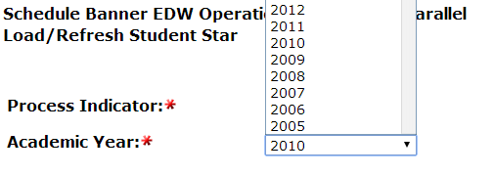

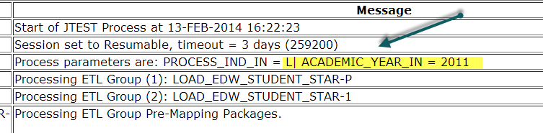

**Cause:**

Parameter set up uses a ‘-‘ (dash) delimiter to decide what to show in the options. Since many of our descriptions also use a dash, this confuses the process, showing only the first part of the description.

For example:

The Ellucian supplied parameter query for academic year is:

select 'ALL' || ' - ' || 'All Academic Years' sel_year_code from dual UNION select distinct year_code || ' - ' || year_code_desc sel_year_code from mgt_year_type_definition where year_type = 'ACYR' order by sel_year_code desc

This generates a list like this:

ALL - All Academic Years

2024 - 2023-2024

2023 - 2022-2023

2022 - 2021-2022

2021 - 2020-2021

2020 - 2019-2020

2019 - 2018-2019

2018 - 2017-2018

2017 - 2016-2017

When the parameters are generated for a job that uses an academic period, the first part is what is returned to the job, but then it cuts out the first part of the description for the display, leaving just the previous year showing.

Since a dash is a common character used in descriptions, we have seen the same problem with aid years.